EXPERIMENT NO.1

STAR TOPOLOGY

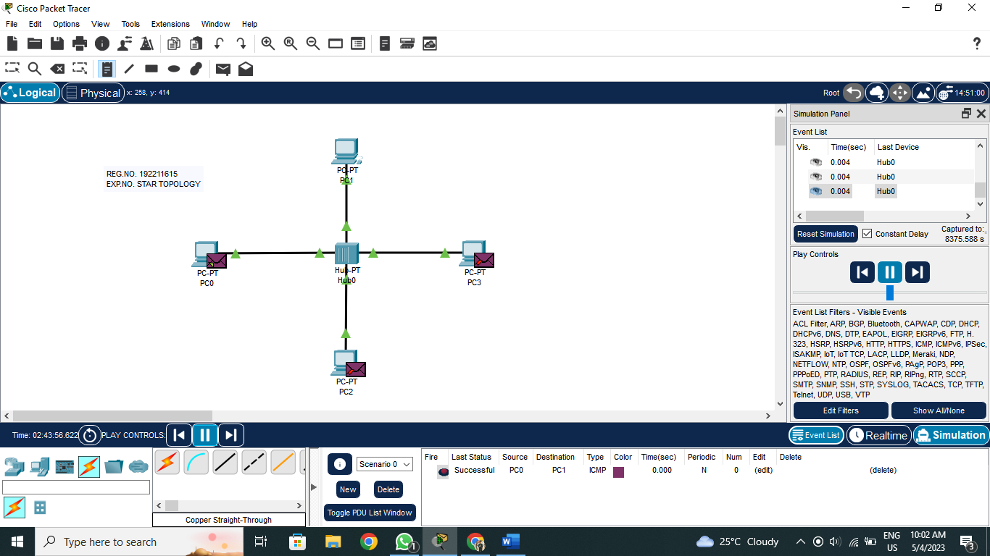

MESH TOPOLOGY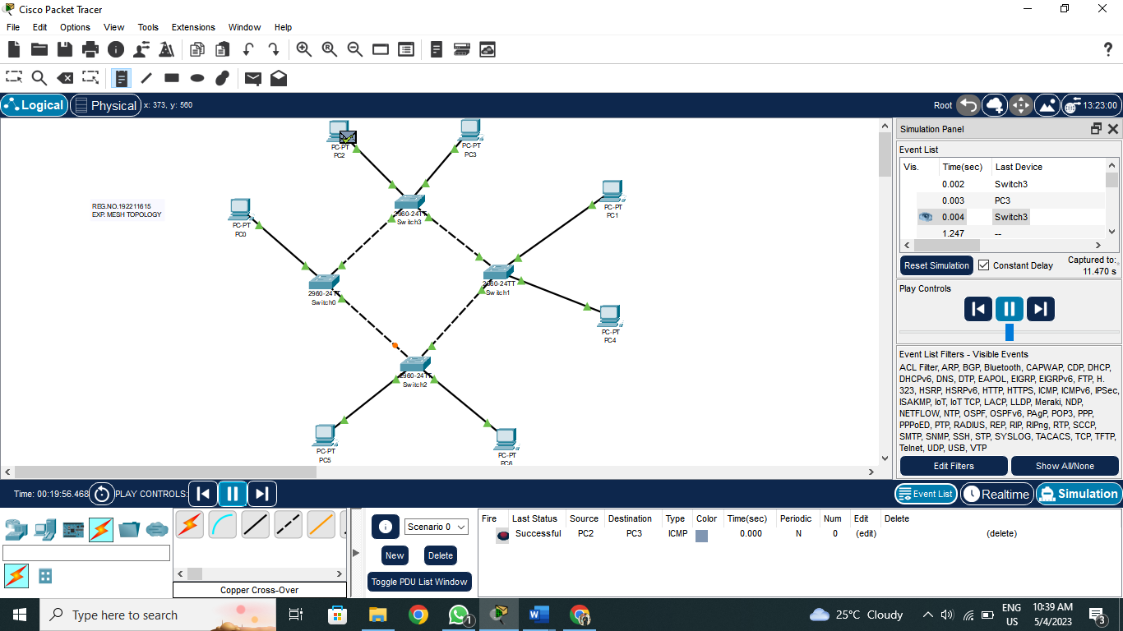

TREE TOPOLOGY

